Ten Prophetic Clues Concerning
Naphtali – Sweden

There is no direct history connecting the tribe of Naphtali to the Swedish people. We are talking about one of the lost tribes. Even the Caucasian population of Sweden comes from various backgrounds. One can compare this to Jewry. The Jewish people have known many proselytes, yet, there has been a core of the tribe of Judah (and some of Levi & Benjamin) over the past 2500 years. The core passes on characteristics and genes to the periphery. Looking at the ‘prophetic clues’ one has to conclude that a core of the tribe of Naphtali once found its way to Sweden. This core passed its characteristics and genes on to the influx of others. The more fulfilled prophetic clues we find, the stronger our case. What follows is not historic proof, but proof by revelation.

1st Clue: Naphtali: my wrestling

And Bilhah Rachel’s maid conceived again, and bare Jacob a second son. And Rachel said, With great WRESTLINGS [naphtulei] have I WRESTLED [niphtalti] with my sister, and I have prevailed: and she called his name Naphtali (Gen 30:7-8, AV throughout, unless noted otherwise).

Rachel had Jacob’s love. Leah did not, but she had offspring, very important in antiquity. There was an ongoing struggle between the two sisters for Jacob’s love. Rachel was the favourite, but Leah got four sons. Rachel was barren. In their ‘wrestling-contest’ Rachel gave her maid Bilhah to Jacob, just like Saraï gave Hagar to Abram in the past.
Bilhah got a son and Rachel named him Dan (judge). But it was not enough. She gave Bilhah to Jacob again. Rachel named Bilhah’s second son Naphtali, ‘my wrestling’, referring to the wrestling with her sister.

Sweden’s wrestle

Like Rachel wrestled with her sister, so the Swedes (Naphtali) wrestled with their brother-tribe Denmark-Norway (Benjamin). After the time of the Vikings the Swedes got into political connections with Denmark and Norway. In 1523 the Swedes were able to gain independence.
Wikipedia: A large number of children inherited the Swedish crown over the course of the kingdom's existence; consequently real power was held for long periods by regents (notably those of the Sture family) chosen by the Swedish parliament. King Christian II of Denmark, who asserted his claim to Sweden by force of arms, ordered a massacre in 1520 of Swedish nobles in Stockholm. This came to be known as the "Stockholm blood bath" and stirred the Swedish nobility to new resistance and, on 6 June (now Sweden's national holiday) in 1523, they made Gustav Vasa their king. This is sometimes considered as the foundation of modern Sweden. Shortly afterwards he rejected Catholicism and led Sweden into the Protestant Reformation.

2nd Clue: Naphtali, a hind let loose
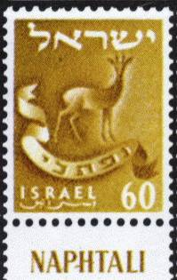
Naphtali is a hind LET LOOSE … (Gen 49:21a).
Nephthali est une biche EN LIBERTÉ … (Gen 49:21a, LSG).
The LORD also spake unto Joshua, saying, Speak to the children of Israel, saying, Appoint out for you CITIES of REFUGE, … And they appointed KEDESH in Galilee in mount Naphtali … (Joshua 20:1-2, 7).

Genesis 49 is about prophecies concerning the tribes in the end time (acharit hayamim, verse 1). Jacob compared the tribe of Naphtali with a female deer, a hind set free.
Something of that freedom can also be seen in the fact that Kedesh in Naphtali was a city of refuge. Sweden has been a ‘city of refuge’ for many over the past decades. Swedes are very fond of their freedom, of their liberty, both nationally and individually.

Swedes, freedom and liberty

Swedes are known for their liberty and their love of personal freedom. Professor Åke Daun is considered to be the godfather of the Swedish soul. Åke Daun:
“Swedes are often serious when they get together,” Daun begins. “There's little skill in conversation and we don't raise our voice, we don't interrupt. We just want to exchange the same ideas and tastes.”
Daun explains why neighbours may well avoid sharing an elevator. “With people they do not know, few Swedes feel moved to talk,” he writes. “Solitude offers ease and liberation. The satisfaction so many Swedes feel when they walk on their own in the woods … derives partly from an absence of social pressure to talk and adapt to others.”



Pipi Longstocking

Another Swedish champion of utter freedom is of course Pipi Longstocking:
Wikipedia: Pippi is portrayed as being a friendly and kind girl, but one with no "proper" manners and having no training or experience in how to behave in normal society, that is, any society other than the very freewheeling and non-regimented one aboard her father’s ship … Her behavior is highly exasperating to many adults … Otherwise she seems trustworthy and loyal to her friends.

Du gamla, du fria

Du gamla, du fria is Sweden’s national anthem, mentioned after its first lines: Thou ancient, Thou free, Thou mountainous north …

Freedom of the press since 1766

https://www.facebook.com/swedense/posts/10155211511969720 :
In 1766 the first freedom of the press act was born in Sweden, and today we've climbed to second place in the global press freedom ranking (May 3rd, 2017).
3rd Clue: Naphtali, goodly words

Naphtali is a hind let loose: HE GIVETH GOODLY WORDS (Gen 49:21).

Genesis 49:21 HA_NOTEN OMREI SHAFER
נפתלי אילה שׁלחה הנתן אמרי־שׁפר

Nephthali est une biche en liberté;
IL PROFÈRE DE BELLES PAROLES (Genèse 49:21).

Swedish language

It is good to emphasize again that according to Genesis 49:1, these prophecies are for the endtime, acharit hayamim. ‘Goodly words’, ‘omrei shafèr’, ‘de belles paroles’, should be applied in the first place to the Swedish language. Swedish is very musical. It sometimes sounds as if they are singing their language.
About Swedish tonality: https://everything2.com/title/Swedish+pronunciation : Tonality
It is the tonality of the language that gives Swedish its characteristic, easily recognizable melody. "The Swedish chef" of TV comedy [The Muppets] doesn't speak Swedish at all, but is immediately recognised by the audience as Swedish, only because of his (rather badly) imitated Swedish tonality.

Standard Swedish is one of the few European languages -- together with Norwegian -- which exhibit tone within words as well as sentences. The functional "questioning tone" - when the tone in an interrogative sentence goes up at the end - is commonplace in most European languages, but in Swedish the tone is applied to all sentences, irrespective of function, and to most words.
Like Chinese, but mostly meaningless.
The predominant Swedish tone is similar to the 3rd tone in Chinese Mandarin (high-low-high, i.e. the tone starts from a certain level, goes deeper down, and then rises up again). Mandarin tones only apply to vowels (and diphthongs) in the monosyllabic Chinese words, but the Swedish tone is also applied to consonants and to polysyllabic words.
Another difference is that the Chinese tones have semantic functions, while the semantic function of Swedish tones is limited to just a few instances - its main role is to give Swedish its characteristic "singing" language melody. If you misplace Chinese tones, then your sentence can easily become unintelligible, while misplaced Swedish tones merely expose you as a foreigner.

Nobel Prizes

Speaking of goodly words, we also think of the Swedish Nobel prizes.
Wikipedia: Alfred Bernhard Nobel (21 October 1833 – 10 December 1896) was a Swedish chemist, engineer, inventor, businessman, and philanthropist. Known for inventing dynamite, Nobel also owned Bofors, which he had redirected from its previous role as primarily an iron and steel producer to a major manufacturer of cannon and other armaments. … After reading a premature obituary which condemned him for profiting from the sales of arms, he bequeathed his fortune to institute the Nobel Prizes.
Wikipedia: Nobel Prizes: The prize ceremonies take place annually in Stockholm, Sweden (with the exception of the peace prize, which is held in Oslo, Norway). Each recipient, or laureate, receives a gold medal, a diploma, and a sum of money that has been decided by the Nobel Foundation. The Nobel Prize is widely regarded as the most prestigious award available in the fields of literature, medicine, physics, chemistry, peace, as is the Prize in Economic Sciences.

More goodly words: Nobel lecture

Wikipedia: According to the statutes of the Nobel Foundation, each laureate is required to give a public lecture on a subject related to the topic of their prize. The Nobel lecture as a rhetorical genre took decades to reach its current format. These lectures normally occur during Nobel Week (the week leading up to the award ceremony and banquet, which begins with the laureates arriving in Stockholm and normally ends with the Nobel banquet), but this is not mandatory. The laureate is only obliged to give the lecture within six months of receiving the prize.

Swedish literature

Swedish literature has produced seven winners of the Nobel Prize in Literature. One of them is Selma Lagerlöf (1909).

4th Clue: Naphtali, favour & blessing

And of Naphtali [Moses] said, O Naphtali, SATISFIED with FAVOUR, and FULL with the BLESSING of the LORD … (Deut 33:23).
And of Naphtali [Moses] said: — O Naphtali, SATISFIED with PLEASURE, And FULL of the BLESSING of Jehovah, (Deut 33:23, YLT).

Even in antiquity Naphtali was satisfied, full of the favour and of the blessing of the LORD. The tribal area of Naphtali was the most fertile of Canaan (eastern Galilee). Josephus called the tribal area of Naphtali ‘a paradise on earth’.

Swedish prosperity

Wikipedia: Sweden is a competitive mixed economy featuring a generous universal welfare state financed through relatively high income taxes that ensures that income is distributed across the entire society, a model sometimes called the Nordic model. Approximately 90% of all resources and companies are privately owned, with a minority of 5% owned by the state and another 5% operating as either consumer or producer cooperatives.
Because Sweden as a neutral country did not actively participate in World War II, it did not have to rebuild its economic base, banking system, and country as a whole, as did many other European countries. Sweden has achieved a high standard of living under a mixed system of high-tech capitalism and extensive welfare benefits. Sweden has the second highest total tax revenue behind Denmark, as a share of the country's income. As of 2012, total tax revenue was 44.2% of GDP, down from 48.3% in 2006.

Social Security in Sweden

Wikipedia: Social security in Sweden is one of the parts of the Swedish welfare system and consists of various social insurances handled by the National Agency for Social Insurance, and also welfare given out on a need basis by local municipalities. … Contents:
1 Child allowance and parental benefit
2 Housing allowance
3 Benefits for ill and disabled
4 Support for the elderly
5 Welfare

Sweden’s blessings

http://theweek.com/articles/528789/trouble-swedish-paradise :
Sweden is blessed with tremendous natural wealth—timber, iron ore, hydropower—and a population with a flair for technology and business creativity. Swedes invented the steam turbine, ball bearings, and the safety match, launching businesses that brought in profits from around the world. Swedish companies, such as the automakers Volvo and Saab, the retailer Ikea, and the telecommunications giant Ericsson, shrugged off the heavy burden of taxes and pensions, and competed ably in global markets. But trouble began to enter the Swedish paradise in the late 1970s.
The term ‘the Swedish Paradise’ is used quite often, both in positive and negative ways. Sweden is full with favour and blessing of the LORD. Their last war was in 1814.

5th Clue: Naphtali, … take the sea / lake

You Naftali, satisfied with favor and full of blessing from ADONAI, TAKE POSSESSION of the SEA and the south (D’varim 33:23, Complete Jewish Bible).
And of Naphtali he said, O Naphtali, … the SEA (Hebr. – yam) and its fishes will be his (Deut 33:23b, BBE).
En van Naftali zei hij [Mozes]: Naftali … NEEM HET MEER [POSSESS the LAKE!] IN BEZIT en het ZUIDEN (Deut 33:23b, Dutch).

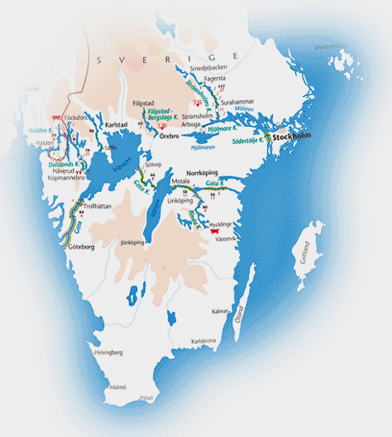
Swedish lakes and canals

Lake of Galilee / Sea of Tiberias

The second part of Moses’ blessing was that Naphtali would take possession of the lake/sea and the south. In Hebrew it says ‘yam’, which can mean lake (of Galilee), inland sea (Dead Sea) or sea (Mediterranean Sea). The Dutch Groot Nieuws Bijbel translates this as ‘take the lake of Kinneret, the lake and its surroundings’.
Sweden and lakes

According to http://www.thelocal.se/20080612/12382 there are at least 100.000 lakes in Sweden. The original Swedes (Svear) lived in the middle of Sweden. They conquered the south and the lakes of the south in the Middle Ages.
The biggest lakes are: Vänern (5519 km²) , Vättern (1886 km²) , Mälaren, Hjälmaren, Storsjön, Torneträsk, Siljan, Hornavan, Akkajaure, en Uddjaure.

Lakes in Finland

For five centuries (ca. 1300 – 1800 AD) Finland was part of Sweden. (There are still 5% Swedish speaking Finns in Finland). Finland has of course even more lakes. According to Wikipedia there are 187,888 lakes in Finland, which are bigger than 500 m².

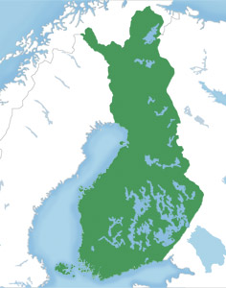
Lakes in Finland

When the Swedes took possession of Finland, they also took possession of its lakes.

Swedish Vikings & the South

It is less known that the Swedish Vikings went south, far into what is modernday Russia.
Wikipedia: The Varangians or Varyags … sometimes referred to as Variagians were Scandinavians, often Swedes, who migrated eastwards and southwards through what is now Russia, Belarus and Ukraine mainly in the 9th and 10th centuries. Engaging in trade, piracy and mercenary activities, they roamed the river systems and portages of Gardariki, reaching the Caspian Sea and Constantinople. Contemporary English publications also use the name "Viking" for early Varangians in some contexts.
The Swedish Vikings also took possession of the sea and the south.

Swedish Golden Age

Naphtali taking possession of the sea (Hebr. yam) and the south is also applicable to Sweden’s Golden Age. The Baltic Sea became more or less a Swedish lake in the 17th and 18th century.
Wikipedia: The Swedish Empire (Swedish: stormaktstiden, "the era of great power") refers to the Kingdom of Sweden's territorial control of much of the Baltic region during the 17th and early 18th centuries, a time when Sweden was one of the great European powers. The beginning of the Empire is usually taken as the reign of Gustavus Adolphus, who ascended the throne in 1611, and the end as the loss of territories in 1721 following the Great Northern War. In Swedish history, the period is referred to as stormaktstiden, literally meaning "the Great Power era".

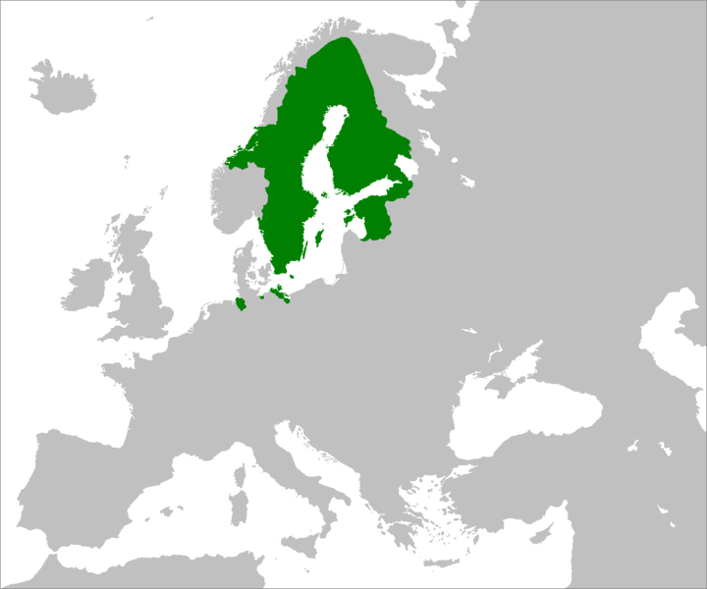
The Swedish Empire turned the Baltic into a Swedish lake in the 17th century

6th Clue: Naphtali … in the north …

The standard of the camp of Dan shall be on the NORTH side … Then the tribe of Naphtali … (Num 2:25, 29).
Now these are the names of the tribes. From the NORTH end to the coast of the way of Hethlon … And by the border of Dan, from the east side unto the west side, a portion for Asher. And by the border of Asher, from the east side even unto the west side, a portion for NAPHTALI (Ezekiel 48:1-3).

Naphtali – North

The tribe of Naphtali is strongly connected with the north. The twelve tribes were placed around the tabernacle in groups of three. Naphtali belonged to the three tribes north of the tabernacle.

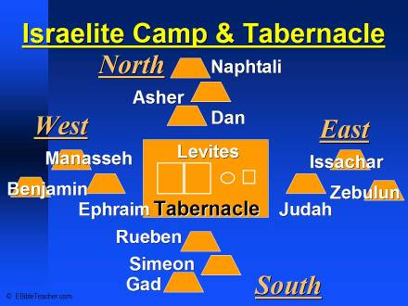
Tribes around the Tabernacle

Land of Naphtali

The land of Naphtali is not just the tribal area of Naphtali, but can mean all of Galilee, the north of Israel (2Ki 15:29; Isa 9:1).

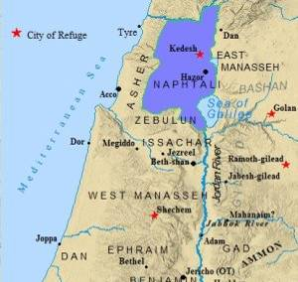
Naphtali in the north

When Joshua gave the tribes their territories, Naphtali became the most northern tribe. The Danites did not arrive up north until the time of the judges.

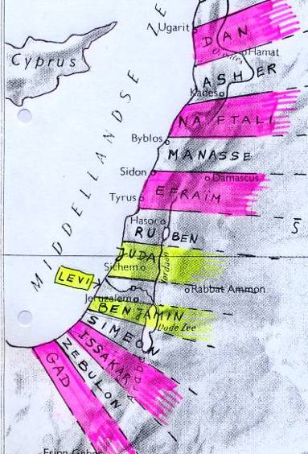
Naphtali in the 7th Millennium,
third tribe from the north
Millennial Reign

Ezekiel 40-46 describes the Temple of the 7th Millennium. Ezekiel 47-48 gives the new tribal areas for the returning remnants of the tribes.
There are many changes in this new tribal order. Zebulun and Issachar no longer live up north, and Judah lives north of Jerusalem instead of south. However, Naphtali stays up north and belongs to the three most northern tribes.

Sweden & the North

The 9 million Swedes are the most northern population of that size. Sweden is situated between the 55th and 70th parallel. Most Canadians and Russians live further south on the globe. Finland (5,5 million), Norway (5 million) and Alaska (735,000) have fewer inhabitants. Sweden is the biggest country of northern Europe.

Swedish national anthem

‘The North’ has a prominent place in the Swedish national anthem. Wikipedia:

Literal translation:

1. Thou ancient, Thou free, Thou
mountainous north,
Thou quiet, Thou joyful beautiful! I greet thee, loveliest land upon earth,
Thy sun, Thy sky, Thy climes green.
Thy sun, Thy sky, Thy climes green.

2. Thou thronest on memories of great olden days, When honoured Thy name flew across the earth, I know that Thou art and wilt remain what thou werest,
Yes, I want to live, I want to die in the North.
Yes, I want to live, I want to die in the North.

4. With God I shall fight for home and for hearth, for Sweden, the beloved native soil.
I trade thee not, for anything in a world
No, I want to live, I want to die in the North!
No, I want to live, I want to die in the North!

The north is a common feature in Naphtali and Sweden. That is clear.

7th Clue: Naphtali, man-woman equality

4 And Deborah, a prophetess, the wife of Lapidoth, she judged Israel at that time.
5 And she dwelt under the palm tree of Deborah between Ramah and Bethel in mount Ephraim: and the children of Israel came up to her for judgment.
6 And she sent and called BARAK the son of Abinoam out of Kedesh NAPHTALI, and said unto him, Hath not the LORD God of Israel commanded, saying, Go and draw toward mount Tabor, and take with thee ten thousand men of the children of Naphtali and of the children of Zebulun?
7 And I will draw unto thee to the river Kishon Sisera, the captain of Jabin’s army, with his chariots and his multitude; and I will deliver him into thine hand.
8 And Barak said unto her, IF THOU WILT GO WITH ME, THEN I WILL GO: BUT IF THOU WILT NOT GO WITH ME, THEN I WILL NOT GO.
9 And she said, I will surely go with thee: notwithstanding the journey that thou takest shall not be for thine honour; for the LORD shall sell Sisera INTO THE HAND OF A WOMAN. And Deborah arose, and went with Barak to Kedesh (Judges 4:4-9).

M/F equality

The story of Barak and Deborah is the one with the greatest male/female equality in the Bible. You have to go and fight Sisera, said Deborah. Only if you come along, said Barak. Barak was a Naphtalite from Kedesh.

Sweden & gender equality

Wikipedia: Women in Sweden: During the Viking Age, women had a relatively free status in the Nordic countries of Sweden, Denmark and Norway … The paternal aunt, paternal niece and paternal granddaughter, referred to as ‘odalkvinna’, all had the right to inherit property from a deceased man. In the absence of male relatives, an unmarried woman with no son could further more inherit the position as head of the family from a deceased father or brother: a woman with such status was referred to as ‘ringkvinna’, and she exercised all the rights afforded to the head of a family clan, such as the right to demand and receive fines for the slaughter of a family member, until she married, by which her rights were transferred to her husband.

Wikipedia: Feminism in Sweden: Women policy makers. Women in Sweden are 45% of the political representatives in the Swedish Parliament. Women make up 43% of representatives in local legislatures. Women are 52% of the Ministers in the Swedish Government (November 2015). While there are no legal quotas for female candidates in Sweden, most parties have internal policies to promote the participation of women … Gender mainstreaming. The Swedish government assesses all policy according to the tenets of gender mainstreaming. Gender mainstreaming is used in government offices, central government agencies, regional governments, municipalities and local government. This has been the case since 1994, with gender mainstreaming meaning that gender, in a stakeholder sense as members of society, is taken into account when government considers new policies … Gender and policy. Sweden has a Minister for Gender Equality. The Swedish government allocates money specifically to gender equality in the annual budget. In 2014 the Swedish government allocated 252 million Krona for gender equality. Swedish political parties across the political spectrum commit to gender-based policies in their public political manifestos.

8th Clue: Naphtali, … copper …

And king Solomon sent and fetched Hiram out of Tyre. He was a widow’s son of the TRIBE of NAPHTALI, and his father was a man of Tyre, a worker in BRASS: and he was filled with wisdom, and understanding, and cunning to work all works in BRASS. And he came to king Solomon, and wrought all his work. For he cast two pillars of BRASS … And he made two chapiters of molten BRASS, to set upon the tops of the pillars … And he set up the pillars in the porch of the temple: and he set up the right pillar, and called the name thereof Jachin: and he set up the left pillar, and called the name thereof Boaz … And he made a molten sea, ten cubits from the one brim to the other: it was round all about, and his height was five cubits: and a line of thirty cubits did compass it round about ... It stood upon twelve oxen, three looking toward the north, and three looking toward the west, and three looking toward the south, and three looking toward the east: and the sea was set above upon them, and all their hinder parts were inward … And he made ten bases of BRASS ... And every base had four brasen wheels, and plates of BRASS ... Then made he ten lavers of BRASS … And Hiram made the lavers, and the shovels, and the basons. So Hiram made an end of doing all the work that he made king Solomon for the house of the LORD … and all these vessels, which Hiram made to king Solomon for the house of the LORD, were of bright BRASS (1Ki 7:13-45).

Great Copper Mountain

Wikipedia: Falun Mine (Swedish: Falu Gruva) was a mine in Falun, Sweden, that operated for a millennium from the 10th century to 1992. It produced as much as two thirds of Europe's copper needs and helped fund many of Sweden's wars in the 17th century. Technological developments at the mine had a profound influence on mining globally for two centuries …
No significant activities had begun before 850, but the mine was definitely operating by 1080. Objects from the 10th century have been found containing copper from the mine. …
By the mid 14th century, the mine had grown into a vital national resource, and a large part of the revenues for the Swedish state in the coming centuries would be from the mine …

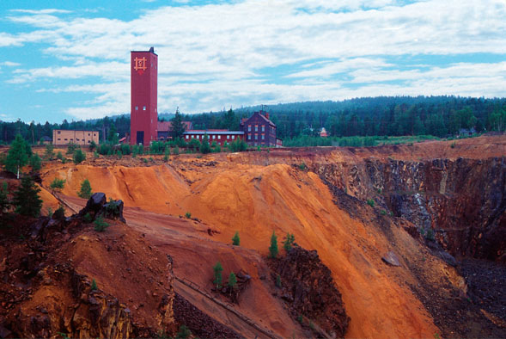
Coppermine in Falun

Golden era. In the 17th century, production capacity peaked. During this time, the output from the mine was used to fund various wars of Sweden during its great power era. The Privy Council of Sweden referred to the mine as the nation's treasury and stronghold. The point of maximum production occurred in 1650, with over 3,000 tonnes of copper produced.
Sweden had a virtual monopoly on copper which it retained throughout the 17th century. The only other country with a comparable copper output was Japan, but European imports from Japan were insignificant. In 1690, Erik Odhelius, a prominent metallurgist, was dispatched by the King to survey the European metal market. Although copper production had already begun to decline by the time he made his report, something Odhelius made no secret of, he stated, "For the production of copper Sweden has always been like a mother, and although in many places within and without Europe some copper is extracted it counts for nothing next to the abundance of Swedish copper".

Falu Red

Wikipedia: Falu red or falun red … is a dye that is used in a deep red paint, well known for its use on wooden cottages and barns. The paint historically originated from various copper mines in Sweden. Most well known is the mine at Falun, in the province of Dalarna … The paint consists of water, rye flour, linseed oil and tailings from the copper mines of Falun …

9th Clue: Naphtali, … darkness … licht …

Nevertheless THE DIMNESS shall not be such as was in her vexation, when at the first he lightly afflicted the land of Zebulun and THE LAND OF NAPHTALI, and afterward did more grievously afflict her by the way of the sea, beyond Jordan, in Galilee of the nations. The people that walked IN DARKNESS have seen A GREAT LIGHT: they that dwell in the land of THE SHADOW OF DEATH, upon them hath THE LIGHT SHINED (Isa 9:1-2).
And leaving Nazareth, He came and dwelt in Capernaum, which is upon the seacoast in the regions of Zebulun and NAPHTALI, that it might be fulfilled which was spoken by Isaiah the prophet, saying, "The land of Zebulun and THE LAND OF NAPHTALI, by the way of the sea, beyond the Jordan, Galilee of the Gentiles: the people who sat IN DARKNESS saw A GREAT LIGHT; and to them that sat in the region and SHADOW OF DEATH, LIGHT has SPRUNG UP." (Matthew 4:13-16, KJ21).

The Jews lived in the land of Naphtali (Capernaum) in darkness, at the time of the New Testament. They saw a great light, Jesus Christ. That is what the prophecy is about in the first place. However, prophecies often have more than one fulfilment. So this prophecy can also be seen as a clue connecting Naphtali with Sweden.

Polar or Arctic Circle

The north of Sweden is north of the arctic circle. Wikipedia: The Arctic Circle … marks the northernmost point at which the noon sun is just visible on the northern winter solstice and the southernmost point at which the midnight sun is just visible on the northern summer solstice … North of the Arctic Circle, the sun is above the horizon for 24 continuous hours at least once per year (and therefore visible at midnight) and below the horizon for 24 continuous hours at least once per year (and therefore not visible at noon) …

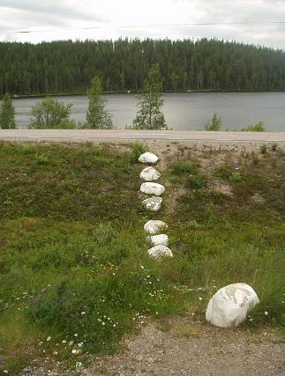
White stones of the polar circle,
south of Jokkmokk

Northern Lights

In northern Sweden the sun does not rise around the 21st December. There is darkness, but from time to time the northern lights can be observed. Wikipedia: An aurora, sometimes referred to as a polar lights or northern lights, is a natural light display in the sky, predominantly seen in the high latitude (Arctic and Antarctic) regions.

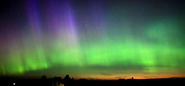
Northern Lights

Walpurgisnight

Walpurgisnight is also celebrated in Sweden. Wikipedia: On the last day of April Walpurgis Night (Valborg) is celebrated throughout Sweden to greet spring. This is done by igniting large bonfires and singing songs celebrating the coming of springtime.

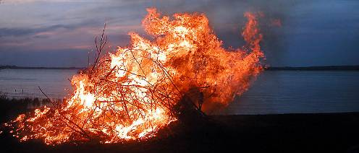
Walpurgis Bonfire in Sweden
Swedish Light Festivals

Wikipedia on Swedish festivals: The second most important festivity in the Swedish calendar, or perhaps for many the most important, is Midsummer, ‘midsommar’. Midsummer's Eve is celebrated on the eve of the Friday between the 20 and 26 June.
Wikipedia: Part of the Swedish tradition is the celebration of Lucia (Saint Lucia Day). She is the only saint to be celebrated in Lutheran Sweden (as well as those parts of Norway and Finland, where Swedish influence has historically been prominent). The celebration, which, however, is not a public holiday, always takes place on 13 December and retains many pre-Christian traditions. The same is also true for many holidays in Sweden … It is said that to vividly celebrate Saint Lucy's Day will help one live the long winter days with enough light.
Lucia / Lucy means light (lux).

Sweden – Safety Matches

Wikipedia: The idea of creating a specially designed striking surface was developed in 1844 by the Swede Gustaf Erik Pasch. Pasch patented the use of red phosphorus in the striking surface. He found that this could ignite heads that did not need to contain white phosphorus. Johan Edvard and his younger brother Carl Frans Lundström (1823–1917) started a large-scale match industry in Jönköping, Sweden around 1847 …
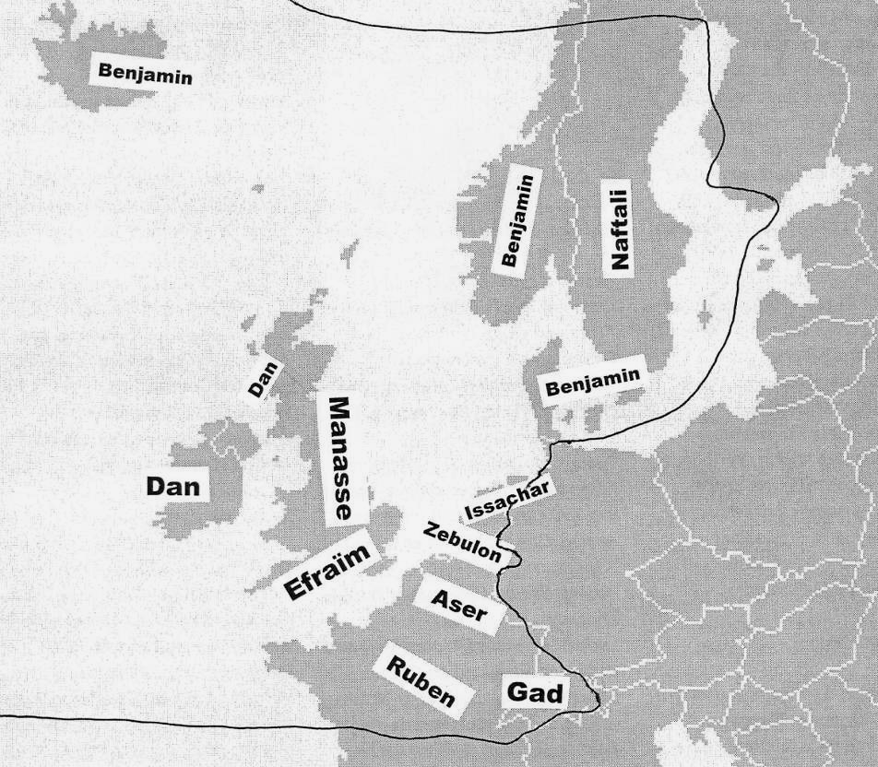
Darkness and light are very prominent in Swedish life and culture. Naphtali sitting in darkness, but seeing many lights. Sweden has also been a great defender (Gustav II Adolph) of the Reformation: a great light. The Bible (light!) was translated into Swedish in 1541.

10th Clue: Naphtali, Naphtali & Joseph

And Laban gave to Rachel his daughter Bilhah his handmaid to be her maid (Gen 29:29). And she gave him Bilhah her handmaid to wife: and Jacob went in unto her … And Bilhah Rachel’s maid conceived again, and bare Jacob a second son. And Rachel said, With great wrestlings have I wrestled with my sister, and I have prevailed: and she called his name Naphtali (Genesis 30:4, 7-8).
And he began then to say: Hear, my children, ye sons of Naphtali, hear the words of your father. I was born from Bilhah, and because Rachel dealt craftily, and gave Bilhah in place of herself to Jacob, and she conceived and bare me upon Rachel's knees, therefore she called my name Naphtali. For Rachel loved me very much because I was born upon her lap; and when I was still young she was wont to kiss me, and say: May I have a brother of thine from mine own womb, like unto thee. Whence also Joseph was like unto me in all things, according to the prayers of Rachel (Testament of Naphtali, Ch.1:5-8).

Rachel Tribes

There are five ‘Rachel Tribes’: Ephraim, Manasseh, Benjamin, Dan (by Bilhah) and Naphtali (by Bilhah). The Anglo-Saxon peoples are descended from Ephraim and Manasseh. Jacob prophesied:
And his father refused, and said, I know it, my son, I know it: he [Manasseh] also shall become a people, and he also shall be great [USA]: but truly his younger brother [Ephraim] shall be greater than he, and his seed shall become a Multitude of Nations [British Common Wealth] (Gen 48:19).
In the Testament of Naphtali, the Patriarch Naphtali claimed a special bond with Joseph, through his mother Bilhah, who gave birth to him on Rachel´s knees. After Rachel´s death Bilhah looked after Joseph and Benjamin.
There is also a special bond among the Rachel Tribes in the endtime. The Leah Tribes are mainly located on the continent of Europe: Issachar (Northern Benelux); Zebulun (Central Benelux); Asher (Southern Benelux); Reuben (France, except for the south) and Gad (parts of Switzerland and eastern France).
The Rachel Tribes are situated in Scandinavia and the British Isles: Dan (Ireland); Joseph (England), Benjamin (Denmark, Norway and Iceland) and Naphtali (Sweden). The Bilhah Tribes Dan (Ireland) and Naphtali (Sweden) are at the flanks of Joseph and Benjamin.
There is a special bond between the peoples of the British Isles and Scandinavia.

Sweden - USA

Naphtali (Sweden) has a special tie with Manasseh (USA). Many Swedes have emigrated to America.
Dutch Wikipedia: Swedes live mainly in Sweden (9 million) and in the United States (4.4 million people of Swedish origin). There are also smaller groups in Canada (330,000) and Finland (300,000). Between 1830 and 1930 about 1.3 million Swedes emigrated to North America, a third of the Swedish population. Especially to Minnesota
There is more, but the above ten clues are the stongest indications for me that the Swedes are from the Tribe of Naphtali.
Bert Otten

Guni, Gunites

Of the sons of Naphtali after their families … of Guni, the family of the Gunites (Num 26:48).
Naphtali had a son named Guni. It is from a different etymological origin, but it is remarkable that many Swedish names start with Gun- : Gunborg, Gunnar, Gunbjörn, Gund, Gundel, Gundhard, Gunfrid,

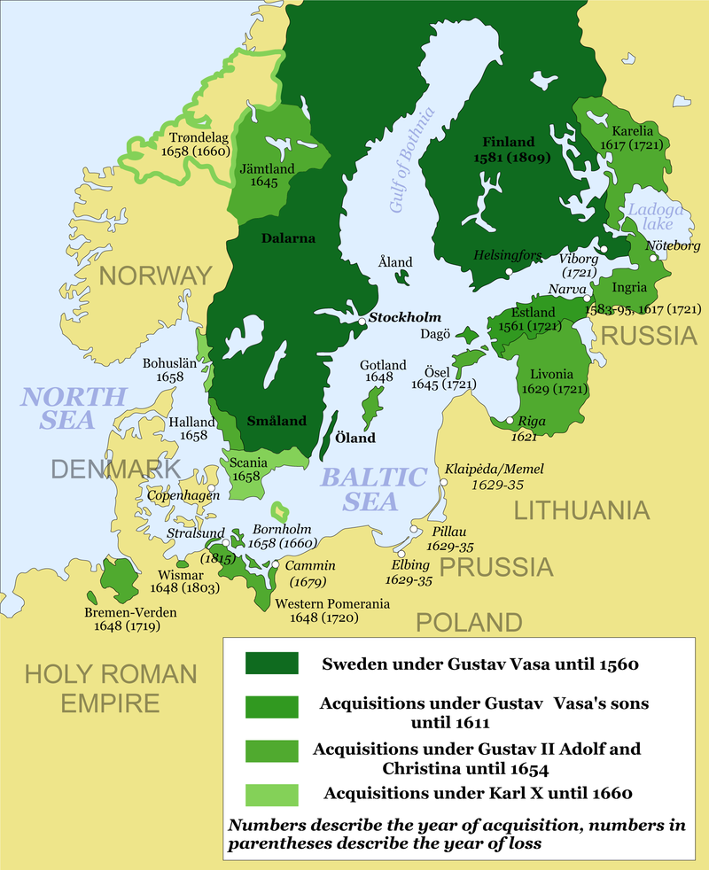

Wikipedia: The development of Sweden and its empire from 1560 to 1815

